LANDIS-II Biomass Insects v2.0

Extension User Guide

Jane Foster1

Robert M. Scheller2

1University of Wisconsin-Madison

2Portland State University

Last Revised: March 12, 2013

# Table of Contents

1 Introduction 4

1.1 What’s New in Version 2.0 4

1.2 Major Releases 4

1.2.1 Version 1.0 4

1.3 Minor Releases 4

2 Insect Biomass Defoliation 5

2.1 Outbreak Temporal Patterns 6

2.2 Defoliation 7

2.3 Defoliation: Outbreak Initiation and Spread 7

2.4 Growth Reduction 9

2.5 Mortality 10

2.6 Acknowledgements 11

3 Primary Input File 12

3.1 LandisData 12

3.2 Timestep 12

3.3 Output Maps 12

3.4 Log File 13

3.5 Insect Input File List 13

4 Insect Input File 14

4.1 LandisData 14

4.2 Insect Name 14

4.3 Temporal Pattern Parameter Inputs 14

4.3.1 Mean Duration and Standard Deviation 14

4.3.2 Mean Time Between Outbreaks and Standard Deviation 14

4.4 Neighborhood Size 15

4.5 Spatial Pattern Parameter Inputs 15

4.5.1 Initial Patch Shape Calibrator 15

4.5.2 Initial Patch Outbreak Sensitivity 16

4.5.3 Initial Patch Distribution 16

4.5.4 InitialPatchValue1 17

4.5.5 InitialPatchValue2 17

4.6 Tree Species Parameters 17

4.6.1 MortalityEstimate 17

4.6.2 Species Name 18

4.6.3 Susceptibility Class 18

4.6.4 Growth Reduction – Slope 18

4.6.5 Growth Reduction – Intercept 18

4.6.6 Mortality – Slope 18

4.6.7 Mortality - Intercept 19

4.7 Susceptibility Class Defoliation Table 19

4.7.1 Susceptibility Class 20

4.7.2 Distribution: Dist80, Dist60, Dist40, Dist20, Dist0 20

4.7.3 Value 1: S1_80, S1_60, S1_40, S1_20, S1_0 21

4.7.4 Value 2: S2_80, S2_60, S2_40, S2_20, S2_0 21

5 Output Files 22

5.1 Output Maps 22

5.2 Log File 22

6 Example File 24

6.1 Primary Input File 24

6.2 Insect Input File(s) 24

# Introduction

This document describes the **Insect Biomass Defoliation** extension for the LANDIS-II model. For information about the model and its core concepts, see the *LANDIS‑II Conceptual Model Description*.

## What’s New in Version 2.0

Version 2.0 of the Biomass Insects extension is compatible with LANDIS-II v6.0.

## Major Releases

### Version 1.0

The original version of this extension was compatible with LANDIS-II v5.1.

## Minor Releases

# Insect Biomass Defoliation

The purpose of this extension is to model landscape-level effects on forest growth and mortality that result from outbreak defoliation events with annual time steps. It incorporates empirical information from satellite-derived maps to capture realistic spatial and temporal patterns of defoliation intensity. Key differences from an earlier LANDIS-II extension for a Biological Disturbance Agent (BDA) include making it functional for annual time steps, partial disturbance, and integrating it with the biomass succession extension (Scheller and Mladenoff 2004; Sturtevant et al. 2004). The LANDIS-II biomass succession extension models basic processes of forest succession including spatially dynamic tree seed dispersal, and tracks accumulation and changes in aboveground live and dead biomass pools for each species cohort at each site.

The **Insect Biomass Defoliation** extension models key aspects of defoliation outbreak dynamics including; disturbance initiation, within-patch variability in intensity and host/non-host response, among-patch disturbance spread and host/non-host response, and disturbance crashes and gradual recovery of surviving hosts. The **Insect Biomass Defoliation** extension (a) stochastically introduces periodic defoliation events parameterized uniquely by defoliator species to capture realistic spatial and temporal patterns, and (b) modifies tree growth and mortality (ANPP) with species-specific response relationships. In addition the extension has the ability to simulate multiple defoliators in the same landscape.

The **Insect Biomass Defoliation** extension determines the amount of leaf biomass lost to defoliation and the amount of growth reduction experienced by each cohort during succession. **Therefore, it is necessary that a Biomass Succession extension is selected that calculates biomass for every cohort.**

The Insect Defoliation extension must operate at an **annual time step**. Unlike other stand replacing disturbances like fire or windstorm that take place at a discrete point in time, defoliation outbreaks typically extend over more than a single growing season, causing persistent stress to trees and stands of host species. Significant responses to defoliation include changes in growth and mortality rates of both host and non-host species that can vary on an annual basis as defoliation stress accumulates. Defoliation outbreaks also tend to spread on an intra-annual basis, thus annual time steps allow more realistic simulation of spatial outbreak dynamics as well as forest response.

## Outbreak Temporal Patterns

Temporal patterns of defoliation outbreaks are captured by drawing from distributions of intra-outbreak intervals and outbreak durations unique for each defoliator being simulated. The form of these distributions is derived from empirical observations of actual intra-outbreak intervals and durations for a given defoliator species.

Intra-outbreak interval is a normally distributed independent variable with a mean and variance defined by the user as input parameters in the insect-defoliator input file (see Section 4.3.2). Insect defoliation outbreaks also have an average duration and variance defined by the user (4.3.1). Outbreak duration follows a negative exponential distribution.

After a new insect defoliation outbreak is initiated, a new intra-outbreak interval and duration is drawn from their respective distributions for the next outbreak. Intra-outbreak interval is counted in years from the start year of the previous outbreak until a new outbreak is initiated. An outbreak will then develop and spread for the length of outbreak duration.

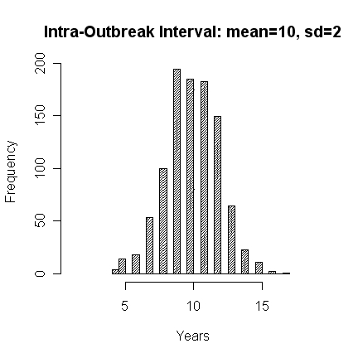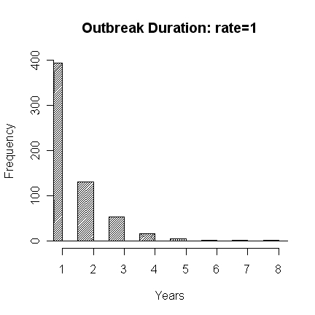

## Defoliation

Defoliation is the amount of leaf biomass removed from the canopy and transferred to the forest floor due to insect outbreaks. It takes the value of a proportion ranging from 0-1, representing 0-100% of the canopy biomass removed by defoliator populations during a single growing season. We also refer to this term as **defoliation intensity**. The amount of defoliation experienced by a species cohort in a given outbreak year is dependent on the susceptibility class of that species, the weighted average susceptibility of all the species cohorts on the site, and the average defoliation experienced by neighboring forest sites in the previous year over an area specified by the user.

## Defoliation: Outbreak Initiation and Spread

Defoliation spatial patterns are “seeded” in the first year of an outbreak by growing defoliated patches that approximate empirical patch size distributions for the landscape. Seed defoliation at each site is drawn from a user specified defoliation intensity distribution (4.7). Expected site level defoliation values for the first year of the outbreak are then drawn from defoliation intensity distributions that vary depending on the average defoliation intensity calculated for the neighborhood surrounding each site. These distributions are called neighborhood dependent defoliation distributions and they are parameterized by the user based on empirical observations. Different defoliation intensity distributions can be parameterized for neighborhoods with average defoliation classes of 0-20%, 20-40%, 40-60%, 60-80%, and 80-100% of foliar biomass removed. “Seeded” defoliation values are drawn from the 80-100% defoliation class. “Expected” site level defoliation is then drawn from the appropriate neighborhood class based on average “seeded” defoliation within the neighborhood. Neighborhood size is also specified by the user (4.4) and covers all sites that fall within a given radius centered on the active site.

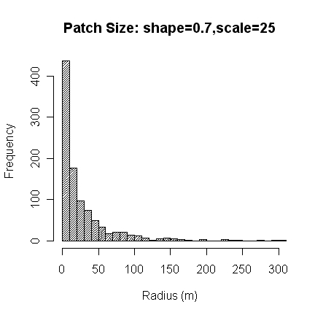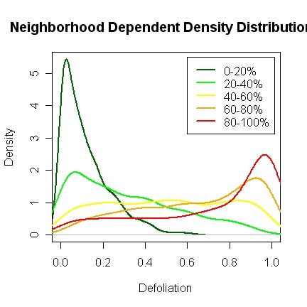

Actual defoliation values for each species at a site are drawn based on the expected site defoliation and the species susceptibility class (4.6.2). All species of the same susceptibility class are defoliated the same amount in a given year and site. Actual site level defoliation is then calculated as the biomass weighted mean of defoliation intensity across all species and cohorts present on the site. Site level actual defoliation is used in the following year if the outbreak continues to calculate neighborhood average defoliation values to determine which distribution subsequent defoliation intensity values are drawn from.

Defoliation is initiated in the first outbreak year based on the joint distribution of defoliation intensity values and defoliation patch sizes characteristic of the landscape. All subsequent outbreak years draw susceptibility class defoliation values from neighborhood specific defoliation distributions.

## Growth Reduction

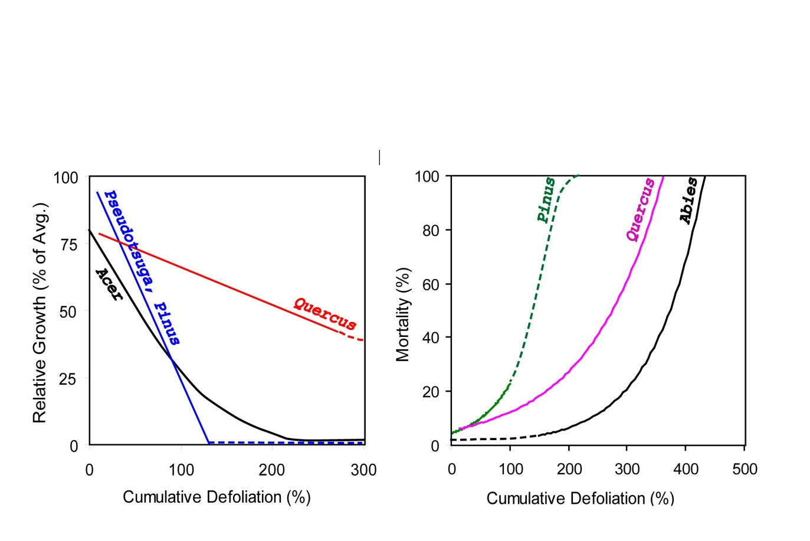Growth reduction is the growth response of individual species and cohorts to a given defoliation intensity. Growth reduction is defined as a reduction in ANPP that results from insect defoliation. Growth decreases from the levels expected in the absence of defoliation stress as a function of the **Cumulative Defoliation** experienced by a species cohort. Cumulative defoliation is the sum of annual defoliation (range 0-1) and can range from 0-*Y*, with *Y* representing the number of years of the duration of the current outbreak, or until all the biomass at a site is dead, whichever occurs sooner. Growth reduction relationships are parameterized by the user for each species in the input files (4.6.4, 4.6.5). Parameters can be derived empirically or extracted from the literature. Relationships should predict relative annual growth (varying from 0-1, i.e. 0-100% of expected or average growth) as a function of cumulative defoliation (0-*Y*). Growth reduction can be linear or negative curvilinear to accommodate the patterns most commonly found in the literature (Foster 2011).

## Mortality

Mortality caused by defoliation stress is a function of the duration and intensity of an outbreak as summarized by the cumulative defoliation. Cumulative defoliation is the sum of the mean defoliation for a site.

Cumulative defoliation is translated into a percentage of the cohort removed by user defined relationships. Empirical analysis shows that mortality increases exponentially as a function of cumulative defoliation over 5-10 years subsequent to an outbreak. The model does not allow mortality to occur until the cumulative defoliation is at least 0.5, and mortality cannot occur in the first year of an outbreak. Mortality always lags defoliation by one year.

There are two methods provided for calculating the percent mortality based on the cumulative defoliation. The first method, referred to as ‘7Year’ uses the following equation:

$$percentMortality=(b×e^{\left(m × cumulativeDefoliation×100\right)}-7)/100$$

Where b and m are parameters derived from empirical data in the literature. This provides a compromise for mortality rate relationships reported in the literature where mortality was measured 5-10 years after defoliation.

The second method for calculating percent mortality, referred to as ‘Annual’ uses the following equation:

$$percentMortality={(e}^{(m × cumulativeDefoliation× 100+b)})/100$$

Where b and m are parameters derived from empirical data in the literature. Parameters for the ‘Annual’ method should be derived from annualized mortality relationships.

Using either method, the percent mortality ranges from 0-1, with 1 representing complete mortality of a cohort. Percent mortality is multiplied times cohort Biomass to determine the amount of biomass removed due to defoliation related mortality resulting from defoliation stress.

## References

Foster, J.R., 2011. Forest insect defoliation patterns and carbon dynamics: Linking remote sensing with simulation models. Dissertation, University of Wisconsin.

Foster, J.R., Townsend, P.A., Mladenoff, D.J. (In Review) Spatial dynamics of a gypsy moth defoliation outbreak and dependence on habitat characteristics. Landscape Ecology.

Scheller, R.M., Domingo, J.B., 2005a. LANDIS-II Core Model Description. University of Wisconsin-Madison, Madison, WI, USA.

Scheller, R.M., Domingo, J.B., 2005b. LANDIS-II Model v5.0 ­– User Guide. University of Wisconsin-Madison, Madison, WI, USA.

Scheller, R.M., Mladenoff, D.J., 2004. A forest growth and biomass module for a landscape simulation model, LANDIS: Design, validation, and application. Ecological Modelling 180, 211-229.

Sturtevant, B. R.; Gustafson, E. J.; Li, W., and He, H. S. 2004. Modeling biological disturbances in LANDIS: A module description and demonstration using spruce budworm. Ecological Modelling. 180: 153-174.

## Acknowledgements

Funding for the development of this extension was provided by NASA Carbon Cycle Science Program and a NASA earth system science graduate fellowship.

# Primary Input File

The input parameters for this extension are specified in **two** **input files**. This text file must comply with the general format requirements described in section 3.1 *Text Input Files* in the *LANDIS-II Model User Guide*.

## LandisData

This parameter value must be “Biomass Insects”

## Timestep

This extension must run on an annual time step, so this parameter value must be 1.

## Output Maps

The next parameter, MapNames, describes where the insect outputs maps are placed, a template for their names and their format. **This convention applies to all map names.** The first portion lists the directory where the maps should be placed relative to the location of the scenario text file (e.g., insect/). The parameter value “{insectName}” must be included and will be replaced with the individual insect name (4.2) for each modeled insect. The parameter value “{timestep}” must also be included and will be replaced with the output time step. Other characters can be inserted as desired to customize the file name template. A meaningful file extension (e.g., .gis, .img) should also be included.

The extension produces 3 series of output maps for each simulated insect (but only the file name for the first is specified):

{insectName}-{timestep}.img : Biomass-weighted percent defoliation (0-100) (i.e. 0-100% of the total foliar biomass in a grid cell).

InitialPatchMap-{insectName}-{timestep}.img: Initial outbreak probability (converted to 0-100 range) for disturbed sites. “InitialPatchMap-” is prepended to the percent defoliation file name.

BiomassRemoved-{insectName}-{timestep}.img: Total biomass removed (/100) for disturbed sites (0.01g/m2). “BiomassRemoved-” is prepended to the percent defoliation file name.

## Log File

The next parameter, LogFile, describes where the log file will be placed and its name. See Section 5.2 for contents of the log file.

## Insect Input File List

The final parameter, InsectInputFiles, indicates which text files to be used for each defoliator insect (see Section 4). An unlimited number of insects can be indicated.

# Insect Input File

For each insect, a separate file containing appropriate parameters is required.

## LandisData

This parameter value must be “InsectDefoliatior”:

LandisData InsectDefoliator

## Insect Name

Set Insect Name parameter to the species of defoliator being simulated:

InsectName GypsyMoth

## Temporal Pattern Parameter Inputs

Temporal patterns are simulated by stochastically drawing from two user defined distributions for the time between outbreaks and outbreak duration. Each distribution is defined by a mean and standard deviation.

### Mean Duration and Standard Deviation

Set these values for the mean and standard deviation of outbreak duration in years for a given defoliator species:

MeanDuration 4

StdDevDuration 2

### Mean Time Between Outbreaks and Standard Deviation

Set these values for the mean and standard deviation of number of years between outbreaks for a given defoliator species:

MeanTimeBetweenOutbreaks 10

StdDevTimeBetweenOutbreaks 2

## Neighborhood Size

The neighborhood size parameter is the radius in meters for a circle centered on each site that represents the neighborhood of cells influencing the probability that a site will experience defoliation of different intensities. For example, if the average defoliation within the surrounding forest neighborhood was very high in a prior year, defoliation intensity values will be drawn from the appropriate distribution with a higher probability of heavy defoliation. Neighborhood size can be inferred from knowledge of insect dispersal abilities or empirically estimated from patterns of residual defoliation and should be considered in relation to the cell length at which a simulation is being run. The use of neighborhood dependent probability distributions for defoliation intensity is the primary mechanism by which defoliation patterns spread and change from one year of an outbreak to the next. Using a larger neighborhood allows more distant sites to affect defoliation, but it can also dilute mean defoliation values used to select defoliation intensity distributions, quashing defoliation more rapidly than desired.

NeighborhoodSize 250 << meters

## Spatial Pattern Parameter Inputs

Spatial pattern parameters are used to initialize the pattern of defoliation in the landscape for a given defoliator species. These patterns are used to seed defoliation patterns in the first year of an outbreak only. These first year patterns can be used to mimic epicenter dynamics, where outbreaks start in a few hotspots and spread, or to mimic defoliator species where outbreaks erupt abruptly over larger areas.

### Initial Patch Shape Calibrator

The initial patch shape calibrator controls the shape of individual outbreak defoliation patches. It ranges from 0 -1. The larger the value, i.e. closer to 1, the less stringent the host requirements for spread become, so as the value of this parameter increases, individual outbreak defoliation patches will take on a more circular shape.

InitialPatchShapeCalibrator 1.0 << must be <= 1.0

### Initial Patch Outbreak Sensitivity

The initial patch outbreak sensitivity controls the proportion of the landscape into which defoliation patches are seeded. It is a modifier for the initial patch distribution and must be greater than 0, usually ranging between 0 and 1. A value of 1 results in no calibration; seeded defoliation patterns will be drawn with no modification from the initial patch distribution described below.

InitialPatchOutbreakSensivity 1 << must be > 0.0

### Initial Patch Distribution

Defoliation outbreaks often appear suddenly, resulting in a large defoliated area even in the first year of an outbreak. In order to capture this sudden onset of defoliation pattern, the initial year of an outbreak is seeded with a defoliation spatial pattern drawn from an initial patch distribution. This distribution is conceptually similar to a traditional patch size distribution that could be derived from traditional defoliation sketch maps or from local autocorrelation analysis of Landsat derived defoliation intensity maps. Patch size in this model is defined by an area in meters. Weibull, Beta or Gamma distributions can be used to define the patch size distribution for the landscape and species of interest. The initial patch distribution is defined by two parameters, Initial Patch Value 1 (Alpha) and Initial Patch Value 2 (Lambda, Theta or Beta).

InitialPatchDistribution Weibull <<Weibull, Beta, or Gamma

>> Patch size distribution should be based on patch radius (meters) distribution.

InitialPatchValue1 .7 <<depends on the distribution, must be > 0.0

InitialPatchValue2 25 <<depends on the distribution, must be > 0.0

### InitialPatchValue1

This parameter corresponds to the scale (mean) for the chosen distribution. This is the “Alpha” parameter for all 3 distributions.

### InitialPatchValue2

This parameter corresponds to the shape (spread) for the chosen distribution. This is the “Lambda” parameter for the Weibull distribution, “Theta” for the Gamma distribution, or “Beta” for the Beta distribution.

## Tree Species Parameters

Tree species parameters follow the keyword SpeciesParameters, and are used to classify the type of host that a tree species represents for a given defoliator and to define unique responses to defoliation stress in terms of reduced growth and increased mortality.

### MortalityEstimate

This parameter specifies which method to use to calculate mortality caused by cumulative defoliation (see Section 2.5). This parameter must match one of the two method keywords: ‘Annual’ or ‘7Year’. Both methods estimate percent mortality as an exponential function of cumulative defoliation over the course of an outbreak. The ‘Annual’ method requires input parameters that have been derived from annualized mortality rate relationships. The ‘7Year’ method was designed to accept parameters from defoliation mortality relationships often reported in the literature without annualized rates. Mortality studies frequently measure and report cumulative mortality rates measured 5-10 years after defoliation outbreaks occur. The ‘7Year’ method assumes a 1% background mortality rate due to successional processes for an average study length of 7 years and subtracts this base rate from the mortality predicted by the model extension. This assures that mortality will not be over-predicted as background mortality is already being accounted for by the Biomass Succession extension. Care should be taken to assure that annualized parameters are used with the correct method.

MortalityEstimate 7Year << 'Annual' or '7Year'

### Species Name

This parameter provides the species name for each row in the tree species parameter table. The names must match species names listed in the general LANDIS-II species input file.

### Susceptibility Class

This parameter currently places each tree species into one of three host preference classes for a defoliator. Susceptibility class 1 represents the most preferred hosts, class 2 represents susceptible but less preferred secondary hosts, and class 3 represents immune hosts that are never defoliated by that species. This information can usually be gleaned from the literature for most well studied defoliators.

### Growth Reduction – Slope

This parameter is the slope for the relationship between cumulative defoliation and relative growth that defines growth response for a given tree species. Currently, this relationship is linear, but a negative curvilinear response will also be implemented. A slope of -1 would mean that a species cohort defoliated 100% would have zero growth in the same year.

### Growth Reduction – Intercept

This parameter specifies the intercept for the above relationship, which should generally take a value of 1, which would mean that with 0 defoliation, growth is 100% of what is expected based on the Biomass succession extension.

### Mortality – Slope

Mortality increases exponentially with increasing cumulative defoliation stress following one of the equations in Section 2.5, depending on which MortalityEstimate is used. The mortality slope parameter represents *m*, and should be empirically derived to reflect mortality responses for a given species or tree functional group.

### Mortality - Intercept

This parameter represents *b* from the above relationship (2.5) and should be empirically derived. This parameter will typically have a value of 0.

>> Species Suscept. Growth Reduction Params Mortality Params  
>> Class Slope Intercept Slope(m) Intercept(b)  
>>---------------------------------------------------------------------  
 ACERRUBR 2 -0.8 1 0.009 7  
 ACERSACC 2 -0.8 1 0.009 7

## Susceptibility Class Defoliation Table

This table defines distributions of defoliation intensity that vary based on host susceptibility class (i.e., 1, 2, 3) and also vary based on the intensity of defoliation in the surrounding neighborhood. These distributions are used to draw the expected defoliation for a site and for a host susceptibility class based on the average neighborhood defoliation intensity. This determines the intensity of defoliation for each species at each site during a defoliation outbreak.

Defoliation intensity is distributed following a Beta distribution, which is bounded from 0 to 1, or 0% and 100% defoliation. These distributions can assume a variety of shapes, from negative exponential to uniform to U-shaped. As neighborhood defoliation increases (i.e. from 0-20% up to 80-100%), the probability of defoliation intensity will shift from most sites experiencing inconsequential defoliation to many sites experiencing heavy defoliation, close to 100%. Modification of these neighborhood dependent distributions controls the flashiness and spread of defoliation from one year to the next.

**Beta Distributions:**

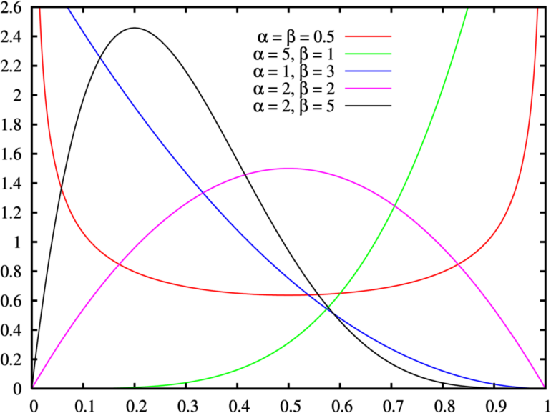

### Susceptibility Class

Corresponds to the three susceptibility classes (1, 2, 3; Section 4.6.3) currently available in the model. Each susceptibility class is assumed to experience a different amount of defoliation given the same defoliator population, and thus each class needs its own probabilities for defoliation intensity.

### Distribution: Dist80, Dist60, Dist40, Dist20, Dist0

This parameter defines the type of distribution that defoliation intensity follows for each class of average neighborhood defoliation intensity. Average neighborhood defoliation classes range from highest - 80-100%, 60-80%, 40-60%, 20-40%, 0-20% - to lowest.

Currently, all distributions follow Beta distributions. This value should be set to Beta.

### Value 1: S1_80, S1_60, S1_40, S1_20, S1_0

1st parameter (Alpha) for the Beta distribution for a given neighborhood defoliation class.

### Value 2: S2_80, S2_60, S2_40, S2_20, S2_0

2nd parameter (Beta) for the Beta distribution for a given neighborhood defoliation class.



Susceptibilities  
>>Host Dist80 S1_80 S2_80 Dist60 S1_60 S2_60 Dist40 S1_40 S2_40 Dist20 S1_20 S2_20 Dist0 S1_0 S2_0  
1 Beta 0.84 0.20 Beta 0.84 0.33 Beta 1.14 1.18 Beta 0.50 2.00 Beta 0.5 6.0  
2 Beta 1.27 0.68 Beta 1.14 1.18 Beta 0.7 2.00 Beta 0.5 3.00 Beta 0.5 6.0  
3 Beta 1 1 Beta 0.8 1.68 Beta 0.7 2.00 Beta 0.5 6.00 Beta 0.2 6.0

# Output Files

## Output Maps

The extension produces 3 output maps for each simulated insect:

{insectName}-{timestep}.img : Biomass-weighted percent defoliation (0-100).

InitialPatchMap-{insectName}-{timestep}.img: Initial outbreak probability (converted to 0-100 range) for disturbed sites. “InitialPatchMap-” is prepended to the percent defoliation file name.

BiomassRemoved-{insectName}-{timestep}.img: Total biomass removed (/100) for disturbed sites (0.01g/m2). “BiomassRemoved-” is prepended to the percent defoliation file name.

## Log File

The log file includes 1 row for each year in which either defoliation or mortality occurred. Each row contains 10 columns of data.

Time: The simulation year represented by the row of data.

InsectName: Name of insect, from parameter file (4.2).

StartYear: The first year of the associated outbreak.

StopYear: The last year of the associated outbreak.

MeanDefoliation: The average defoliation (proportion canopy removed) across all defoliated sites.

NumSitesDefoliated0_33: The number of sites with defoliation between 0 and 0.33 (low intensity).

NumSitesDefoliated33_66: The number of sites with defoliation between 0.33 and 0.66 (moderate intensity).

NumSitesDefoliated66_100: The number of sites with defoliation between 0.66 and 1 (high intensity).

NumOutbreakInitialSites: The number of outbreak patches seeded in the initial outbreak year.

MortalityBiomass: The total species biomass removed due to mortality following cumulative defoliation (g/m2).

# Example File

## Primary Input File

LandisData "Biomass Insects"

Timestep 1

MapNames Insects/{insectName}-{timestep}.gis

LogFile Insects/Insect-log.csv

InsectInputFiles insect-defoliator.txt

## Insect Input File(s)

LandisData InsectDefoliator

InsectName GypsyMoth

MeanDuration 5

StdDevDuration 0

MeanTimeBetweenOutbreaks 7

StdDevTimeBetweenOutbreaks 0

NeighborhoodSize 250 << meters

InitialPatchShapeCalibrator 1.0 << must be <= 1.0 Higher = Rounder; Lower = tracks host quality closer.

>> Lower this number to lower probabilities of patch generation, i.e. start fewer patches.

InitialPatchOutbreakSensitivity 0.02 << must be > 0.0

InitialPatchDistribution Weibull <<Weibull, Beta, or Gamma

>> Patch size distribution should be based on patch area distribution.

InitialPatchValue1 0.7 <<Alpha parameter, must be > 0.0

InitialPatchValue2 25 <<depends on the distribution, must be > 0.0

SpeciesParameters

MortalityEstimate 7Year << 'Annual' or '7Year'

>> Susceptibility class by species (from Liebhold et al 1995)

>> Species Susceptibility GrowthReduction MortalityParameters

>> Class Slope Intercept Slope Intercept

>>-------------------------------------------------------------

abiebals 2 -1 1 0.1 0

acerrubr 2 -1 1 0.1 0

acersacc 2 -1 1 0.1 0

betualle 2 -1 1 0.1 0

betupapy 1 -1 1 0.1 0

fraxamer 3 -1 1 0.1 0

piceglau 3 -1 1 0.1 0

pinubank 3 -1 1 0.1 0

pinuresi 3 -1 1 0.1 0

pinustro 3 -1 1 0.1 0

poputrem 1 -1 1 0.1 0

querelli 1 -1 1 0.1 0

querrubr 1 -1 1 0.1 0

thujocci 3 -1 1 0.1 0

tiliamer 2 -1 1 0.1 0

Neighborhood Class Table

>> Host Dist80 S1_80 S2_80 Dist60 S1_60 S2_60 Dist40 S1_40 S2_40 Dist20 S1_20 S2_20 Dist0 S1_0 S2_0

1 Beta 0.84 0.33 Beta 1.27 0.68 Beta 1.14 1.18 Beta 0.76 1.68 Beta 0.8 6.0

2 Beta 1.27 0.68 Beta 1.14 1.18 Beta 0.8 1.68 Beta 0.5 1.68 Beta 0.7 6.0

3 Beta 1 1 Beta 0.8 1.68 Beta 0.5 1.68 Beta 0.3 1.68 Beta 0.5 6.0